ENGINEERING RESPONSE
Name
Institution
Date
Important steps to install bolts with proper torque
In mechanical engineering, application of the exact and right amount of torque is vital for proper clamping between the engine block and the idler pulleys. There tends to be a lot of assumptions and mechanics getting a conviction that they are tightening bolts using the proper torque wrench (Joe, 2017). This has often led to the abuse of torque specifications. The consequences of excessive or little torque can lead to damaging of the engine.
All bolted joints are specific and unique thus requiring the need to establish the appropriate tightening torque pertaining each application. Keen experimentation is always the best way that the optimum torque requirement can be realized. This experimentation results to the required torque. Factors to consider when establishing the correct torque include the following (Joe, 2017): a) diameter of the bolt – diameter is directly proportional to the fore applied in a given bolt. This means bolts with large diameters will require more force as compared to ones with small diameters, b) grade of the bolt – material strength is the specific factor when we talk of grade. For instance, a SAE Grade eight demands more stretch force than SAE Grade five, c) frictional coefficient – this is the nut factor. Threads and other bolt bearing surfaces that are smooth, hard and slick need less stretch force or torque as compared to rough, soft and sticky surfaces. With the above considerations, mechanics find a provisioning for the initial torque targeting which is reached at by the product of the above factors, that is: T (torque) = K (an estimated frictional coefficient)*D (bolt diameter in inches)*P (anticipated tensile load of the bolt in pounds). This formula allows for the stimulation of the exact application to arrive at the anticipated load (P) which is indicated. Then the required tension is the exact tightening torque requirement for the specified application.
Explain the use of correction factors when torque wrench adaptors are used to reach tight spaces
Although fasteners are often checked, it is not possible to accurately establish whether they have been fitted to the recommended torque. However, some maintenance processes are found to examine torques hence the use of correctional factors, in case a lapse is found.
As a start, torque is loosened from the fastener to the extent of no preload. This is the initial step of correction. Tare toque is then measured after which torque specification for the application at hand is established (Smith, 2010). This torque is then added to the tare torque to arrive at the assembly torque. This is now the value that the torque is fastened to.
How is torque distributed in the bolt?
Bolts act the kind of springs to clamp parts. Torque distribution is dependent on a number of factors but majorly, its distribution takes the following order. Under head friction takes the much torque, about 60 percent. The tension takes 10 percent and thread friction takes 30 percent.
Why measure and control torque if bolt tension is really the important parameter when securing bolts?
Torque measurement and control is required prior to Assembly since it forms a definite technique to conduct torque capability studies. Torque is bound by specifications and that is why its measurement is vital. For potential applicability, torque need to be consistent to meet mechanic needs.
Torque Sensor audits an application’s torque specifics as a way monitoring specifications. There is a system that reads and records data to improve privacy terms (Mountz, 2017).
Part 2:
Important riveting steps to install flush, countersunk; and important rivet dimensions
Flush riveting is one of the most preferred fastening. Together with counter riveting and CSK riveting, the industry of their operation has developed. This mechanism utilizes the countersunk rivets combining the metal and decorating the appearance.
The procedure for installing flush rivets is as highlighted below:
- Using a drill or a punch, holes are made with CSK of specified dimensions
- Blind Rivets are inserted to co-join the given number of sheets according to the strength desired
- With the help of a pneumatic tool or any physical manual, the rivets are set
- A perfected flush surface is achieved from one side
Counter sunk riveting
The difference that exists between flush riveting and counter sunk riveting is that counter sunk rivets are achieved with special cutting bit which tend to mold depressions that are cone shaped for flush fasteners or rivets. It does not allow drilling much bigger rivet holes despite the thickness of the surface skin. There is a threshold requirement for the metal skin measurement so as to be countersunk perfectly.
Counter sunk riveting is a one piece fastener which allows for an excellent choice of flush application. Unlike in the case of a CSK screw, countersinking guarantees the clamping effect and not just by holding. Talking of strength, counter sunk rivets load bearing joints. They are available in steel and stainless steel purposely to load bearing and corrosion resistance.
Installing counter sunk rivets
Whole drilling; holes for riveting are centre punched before they are dried out using a sinker. This is done to ensure that the drill will stay steady and free from slipping.
De-burring; rechecking for correct hole drilling and keeping them smoothened for all burrs.
Counter sunk riveting dimensions
The below table represents important dimensions used in overall riveting:
Rivet Diameter (inches) | Best Drill | Common Drill | Hole size
3/32 | #40 | 7/64 | 0.096
1/8 | #30 | 9/64 | 0.128
5/32 | #21 | 11/64 | 0.159
3/16 | #11 | 13/64 | 0.191
7/32 | #10 | 15/64 | 0.225
¼ | #F | 17/64 | 0.257
5/16 | #P | 21/64 | 0.323
3/8 | #W | 25/64 | 0.386
7/16 | 29/64 | 29/64 | 0.453
½ | 33/64 | 33/64 | 0.516
 | Rivet Pilot Hole Size

Counter sink versus dimple: Basic measurement: 0.032 or thinner (dimple). Thicker than 0.032 (countersink). This means that a sheet of 0.032 is countersunk with 3/32 rivets although care is observed as it is not preferred for large areas. 0.040 Measured sheet is preferable to dimple but not condoned but the rivet must counter suck with a 100 degrees sinker. A complete flush rivet head is not supposed to deviate the surface of the sheet by negative or positive 0.002 inches. 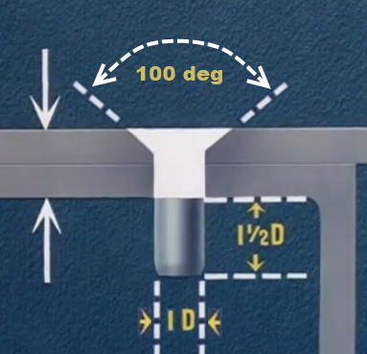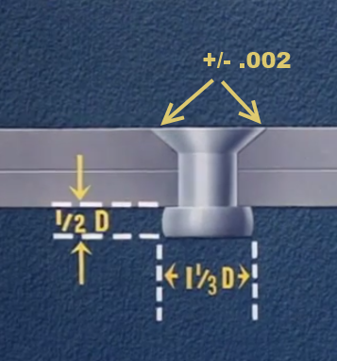
Double dimple; this methods accommodates sheets of 0.040 or thinner to perform fast. Rivet is the dimple which is taken lightly against a female dimple at 110 or 120 degrees. 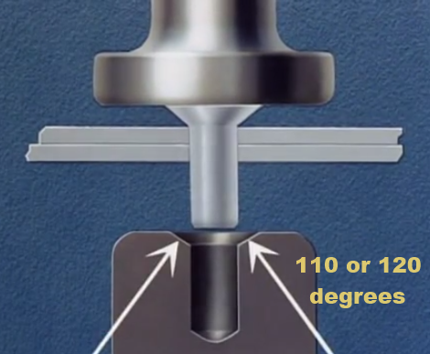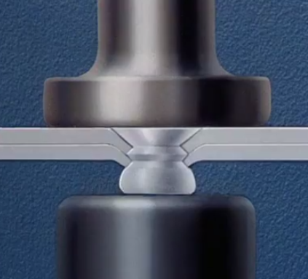
Pre dimple: this method can also be used with a sheet of measurement 0.040 or thinner. Holes are drilled properly and fit angles are put in place as shown;
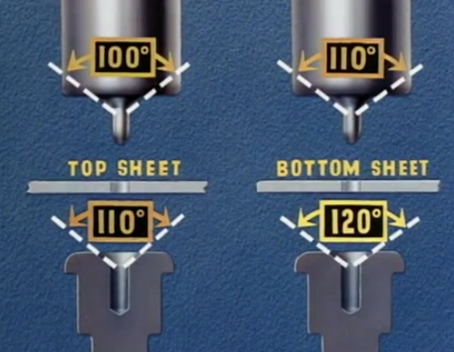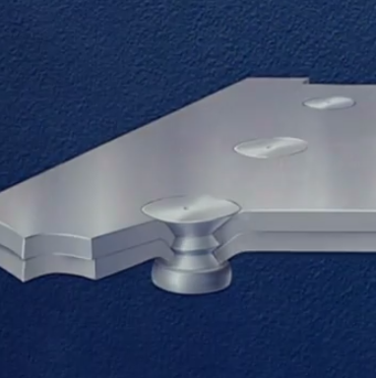

Countersunk; a bottom of 0.040 or thinner but a top of the same dimension but thicker now
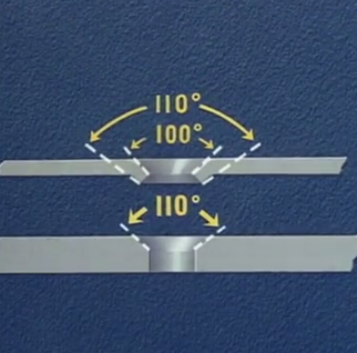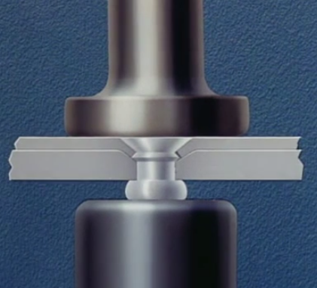

References
Doityourself (2017). Installing countersunk rivet
Jan Zumwalt, (20170. Four Methods Of Flush Riveting – Walt Disney Industrial Trainings Films (p. 1942).
Joe Greenslade (2017). Zero Products Inc. What is the Proper Torque to Use on a Given Bolt?
Mountz (2017). “Measuring Torque in 3 Facets of the Assembly Process Improves Quality Control & Reduces Rejection Rates.”
Smith Rena, (2010). Using a torque wretch to inspect a bolt for proper torque.

